Technology
Year (s) 3/4 | Situation/Big Question: To Grow or not to Grow. What helps? Can we set up a system that will grow a plant over winter using hydroponics? |  | Duration 3-4 weeks
Key Competencies: (Highlight one focus key competency) |  | Values (Highlight one focus value)
Thinking; Using Language, symbols and text, Managing self; Relating to others; Participating and Contributing |  | Excellence; Innovation; Inquiry and Curiosity; Equity; Community and Participation; Ecological sustainability; Integrity; Respect

Level: 1 | Achievement Objectives – Technological Practice
Planning for Practice (PP)
Describe the outcome they are developing and identify the attributes it should have, taking account of the need or opportunity and the resources available.
Brief Development (BD)
Outline a general plan to support the development of an outcome, identifying appropriate steps and resources.
Outcome development and evaluation (ODE)
Investigate a context to communicate potential outcomes. Evaluate these against attributes; select and develop an outcome in keeping with the identified attributes.
Achievement Objectives – Technological Knowledge

Technological modelling (TM)
Understand that functional models are used to represent reality and test design concepts and that prototypes are used to test Technological Outcomes
Technological products (TP)
Understand that technological products are made from materials that have performance properties.
Technological systems (TS)
Understand that technological systems have inputs, controlled transformations, and outputs.

Achievement Objectives – Nature of Technology

Characteristics of technology (CT)
Understand that technology is purposeful intervention through design
Characteristics of technological outcomes (CTO) Understand that Technological Outcomes are products or systems developed by people and have a physical nature and a functional nature

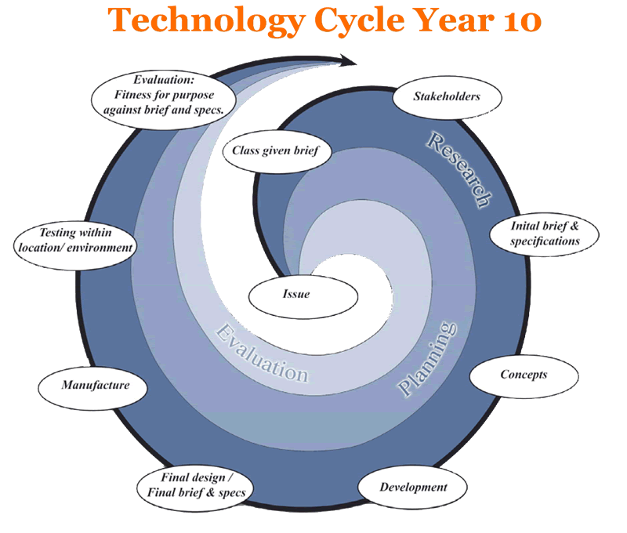 | Teaching and Learning Experiences  (bullet point list of experiences) | Learning Outcomes  (Assessment Focus)
 | Intro to systems  Session 1 (30 mins)  What are systems? Record ideas, questions  Look at photos – toaster, washing machine  Funny photos – jobs in town (see powerpoint)  Videos - crème egg smash and Rube Goldberg machine  Explore misconceptions - natural, social, organizational, technological – (see powerpoint) activity  Key ideas about systems I want children to understand  There is an input, transformation and output  Session 2(40 mins)  Input and output activity  There is a human input and then the system operates and produces an output. These inputs might include raw materials, information and energy.  Card sort  Look at these systems and identify what the input and output is. (see powerpoint)  Transformation activity  During the process inputs are transformed in a controlled fashion. Systems will control and transform energy, information and materials.  Pick a simple system and draw a picture of what is happening inside it. What is the transformation?  Session 3 (40 mins)  Intro to hydroponics ( Issue, brief and Research)  Issue – We haven’t got a lot of spare garden and soil space at school. How could we grow plants all year around without using a garden? Brainstorm ideas  Show photos of hydroponic set ups  What is happening? How does it work? Where is the soil? How are they growing? Any other questions children want to ask?  Brief – set up a simple (passive) hydroponic system to grow a plant  Specifications – develop these with the children 3-4 specific things that our system should have.  Research- looking at photos/books/websites  http://love2learnnz.wikispaces.com/Hydroponics+in+the+Classroom  Visit hydroponic green houses –Saddleview nurseries  Session 4(30 mins)  Re-cap issue, brief, specifications  Planning/concept – sketch a plan for your system – label the materials needed. (show the you tube vid and bottle diagram)  Session 5 (40 mins)  Development  Make the hydroponic system and plant lettuce or herb  Ongoing testing/caring/observation/recording growth  Session 6 (30mins)  Evaluation  Based on the brief and specifications children will evaluate their system, outcomes etc. Comments will be posted on techspot blog page | TP  TK  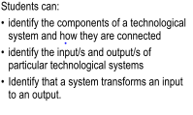  NoT
Key Resources
http://www.hydroponics101.com/sw63175.php
http://www.youtube.com/watch?v=MAW-cHu5Yp8
http://www.youtube.com/watch?v=0uDDEEHDf1Y

Thinking Strategy/Tool

E-Learning Tools
Websites
Powerpoints

Te Reo/Tikanga

Community Links
Visiting hydroponic nursery

